C ++ file

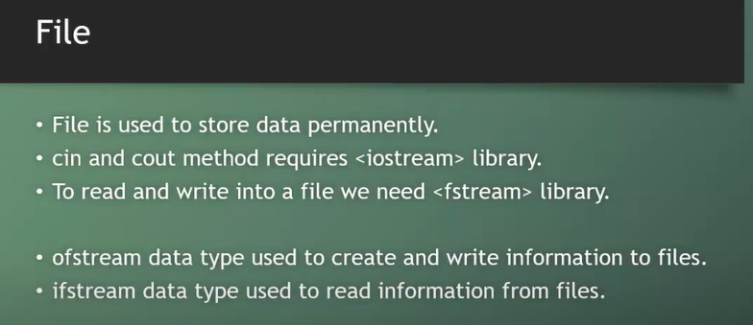

File open and write code:

#include<iostream>

#include<fstream>

using namespace std;

int main()

{

    string name;

    ofstream file;

    file.open("student.txt");

    file << "I am Rangan. I am 20 years old.\n";

    file.close();

    return 0;

}

Result:

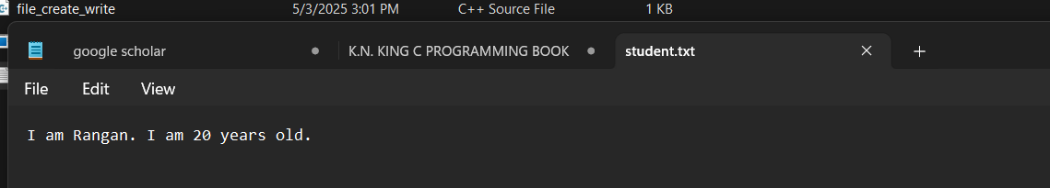

User input code:

#include<iostream>

#include<fstream>

using namespace std;

int main()

{

    string name;

    ofstream file;

    file.open("student.txt");

    cout << "Enter your name : ";

    getline(cin,name);

    file << "Welcome " << name << endl;

    file.close();

    return 0;

}

Terminal:



Result:

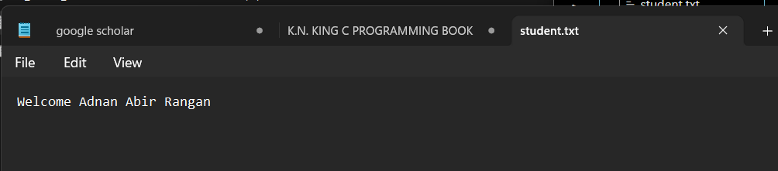

Append

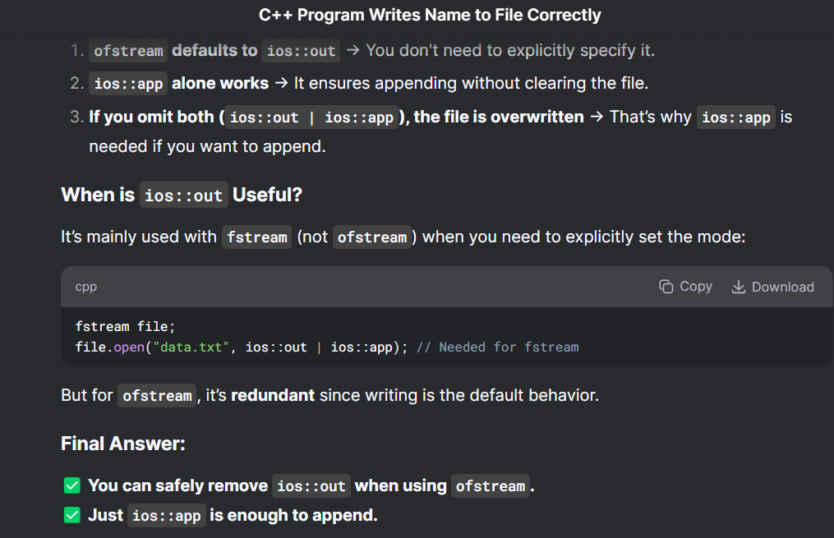

Append to previous file code:

#include<iostream>

#include<fstream>

using namespace std;

int main()

{

    string name;

    ofstream file;

    //file.open("student.txt" , ios::out|ios::app); //need to use it when using fstream as datatype

    //or

    file.open("student.txt" , ios::app); //better to use while using ofstream datatype

    cout << "Enter your name : ";

    getline(cin,name);

    file << "Welcome " << name << endl;

    cout << "Data is stored\n";

    file.close();

    return 0;

}

Terminal:

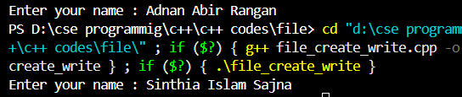

Result:

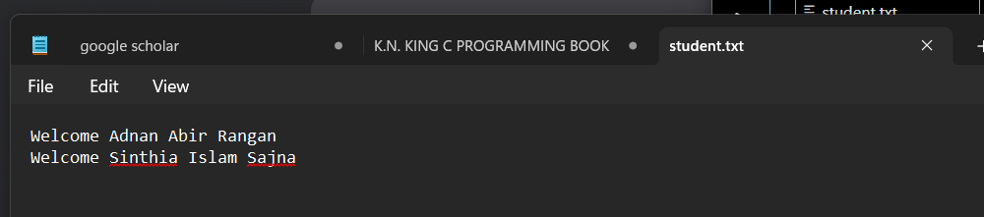

Student details code:

#include<iostream>

#include<fstream>

#include<limits>

using namespace std;

int main()

{

    string name;

    int age;

    ofstream student_file;

    student_file.open("student_details.txt" , ios::app);

    for(int i = 0; i < 4; i++)

    {

        cout << "Enter your name : ";

        getline(cin, name);

        student_file << name << "\t";

        cout << "Enter your age :";

        cin >> age;

        student_file << age << endl;

        cin.ignore(numeric_limits<streamsize>::max() , '\n');

    }

    student_file.close();

    cout << "Data was stored!\n";

    return 0;

}

Terminal:

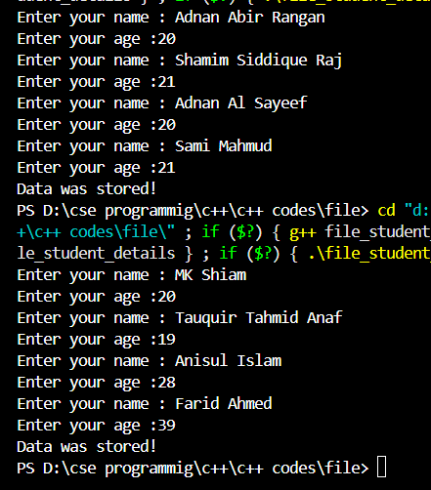

Result:

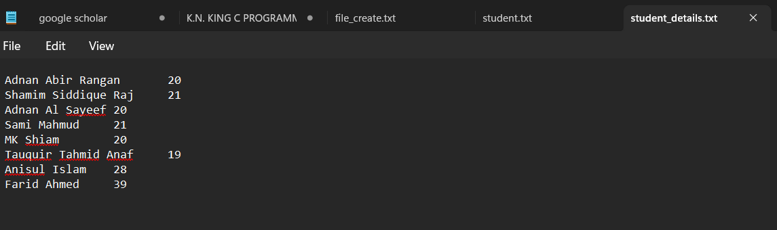

File read code:

#include<iostream>

#include<fstream>

using namespace std;

int main()

{

    string line;

    ifstream file("student_details.txt");

    while(getline(file , line))

    {

        cout << line << endl;

    }

    file.close();

}

Result:

